

Prepared by:

**Gerber Technology**

**YuniquePLM**

**Share Folder**

The Share Folder is an area where any items that have been “shared” with outside agents or vendors can be accessed easily. It is an area where each user can filter the views of these items according to user specified criteria. To access the share folder, click on the header located on to the far right of the desk top window.

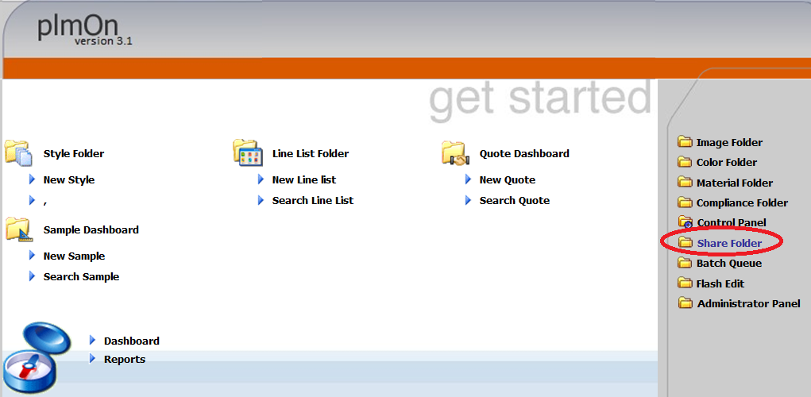

Once the Share Folder is opened a list of all available agent partners will be presented on the right side of the window by clicking on the Agent node on the left. The list can be filtered by entering data in the search fields across the top of the window.

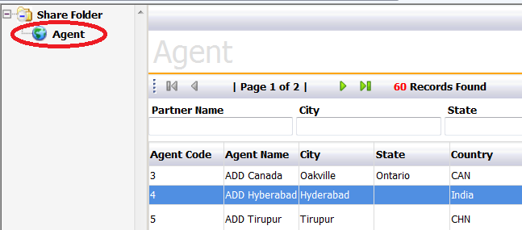

Select a specific agent by double clicking on the name in the list. This will open up all shared records for that agent.

The records will be presented on three tabs according to record type. The tabs are labeled Tech Packs, Quotes, and Samples.

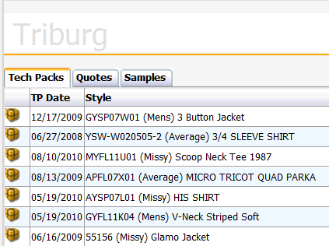

The records on each tab are presented in a list form. By double clicking on a specific record a user can open up the actual style folder or sample request and make edits to the record or view the details according to the permissions that have been given to login account.

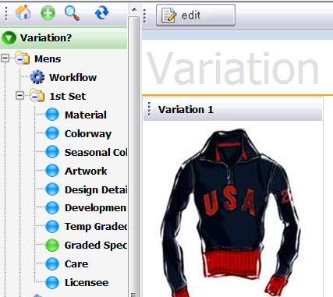

The functionality available for tech packs, quotes and sample request is the same as it is if an individual style record is opened. The Share Folder simply offers a way to view multiple records at one time.